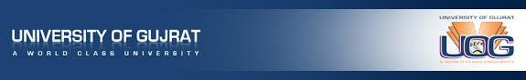

To Whom it May Concern

I am delighted to provide a recommendation letter for **Mustansar Nawaz**, who is eager to pursue a **Master's** at your esteemed institution. I have known Mustansar Nawaz since 2019 when he enrolled in the Bachelor of Science in Mechanical Engineering and Technology program at the University of Gujrat in Gujrat, Pakistan. In 2023, he completed his Bachelor of Science in Mechanical Engineering and Technolog from the University of Gujrat.

During his academic journey, I had the privilege of teaching him the “Hydraulic machinery” course. Mustansar Nawaz demonstrated exceptional dedication to his studies and completed his degree within the designated timeframe. He consistently exhibited responsibility, punctuality, and an exemplary work ethic. Moreover, he showcased excellent research skills, as evident in the quality of his work on his thesis project. Mustansar managed to devise elegantly simple solutions to complex problems, highlighting his ingenuity.

His presentation and management skills were noteworthy, underscoring his ability to communicate and lead effectively. I hold Mustansar in high regard for his decision to pursue his specific research interests at your university. I am confident that he will be a valuable addition to your MS program, where he can further develop and apply his exceptional talents.

Sincerely,

Dr Sajjad Miran Associate Professor

Department of Mechanical Engineering University of Gujrat [sajjad.miran@uog.edu.pk](mailto:sajjad.miran@uog.edu.pk)